Akanksha

Mentors:  Savitha Sridhar, Gayathri, Sai Geetha

diet Program

**Diet Program**

**Introduction:**  
Diet Program is an Online-based public service program, which helps people in maintaining their diet by taking help from experts. This application consists of several groups classified based on the BMI (above 25 and below 25). In each group, relevant tips and plans will be shared on how to maintain a healthy diet.

**End-users:**

This application classifies users into 3 types. They are Admin, Moderator and Users. Here Admin is the main root user, who can perform all actions. Such as Posting in group, Approving and Rejecting user requests, Promoting users and Removing users. Whereas Moderator is someone who was once a user, now promoted as moderator who can also perform certain actions in that particular group. Messages, Links and Files regarding Tips and Diet Plans will be posted in appropriate group by Admin/Moderators, where users from that group can make use of it.

**Technologies/Tools used:**

1. **Frontend : Angular 7, StompJS**
2. **Middleware : RabbitMQ, Restful**
3. **Backend : Java 8 ( Springboot )**
4. **Database : In-memory H2 database**
5. **IDE : Spring Tool Suite**

**Database Structure:**

1. **Users** :

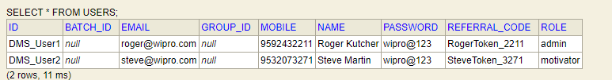

2. **Challengers** :



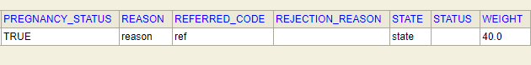

3. **Monthly Measurement** :   
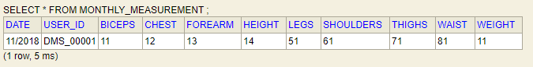

4. **Daily Activity Log** :

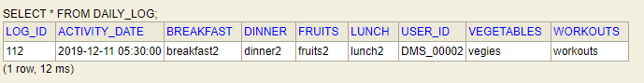

**UI Screenshots :**

1. **Login Page** :

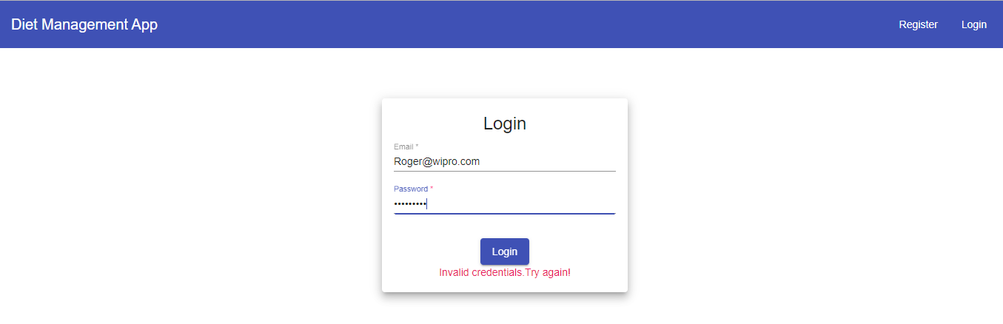

2. **Admin Menu** :

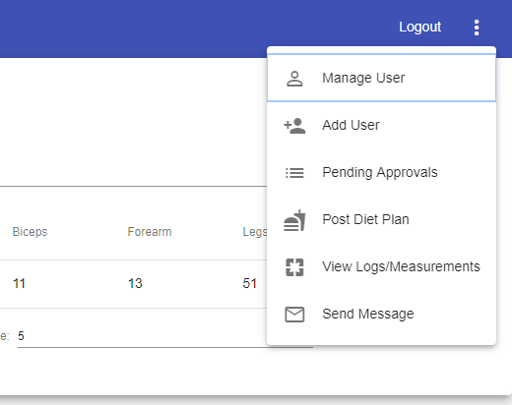

3. **Admin Dashboard – Pending approvals** :

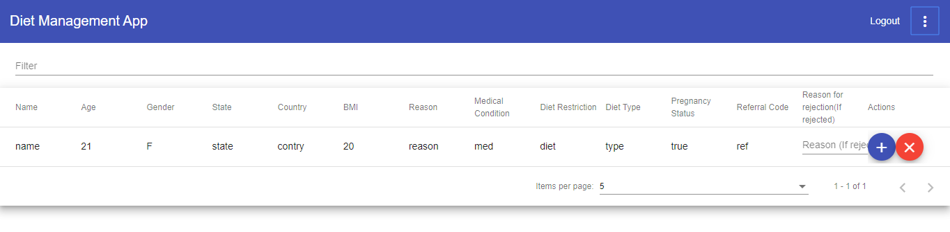

4. **Admin Dashboard – Manage approved users** :

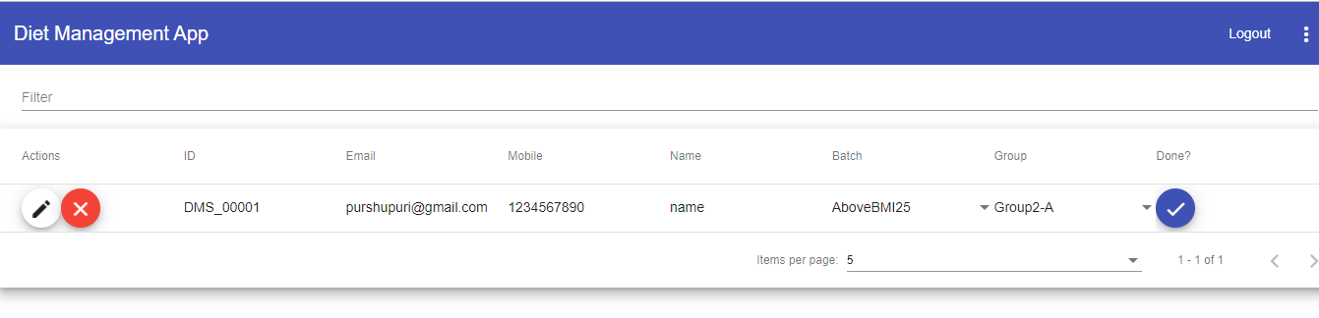

5. **Admin – View daily user activity logs**:

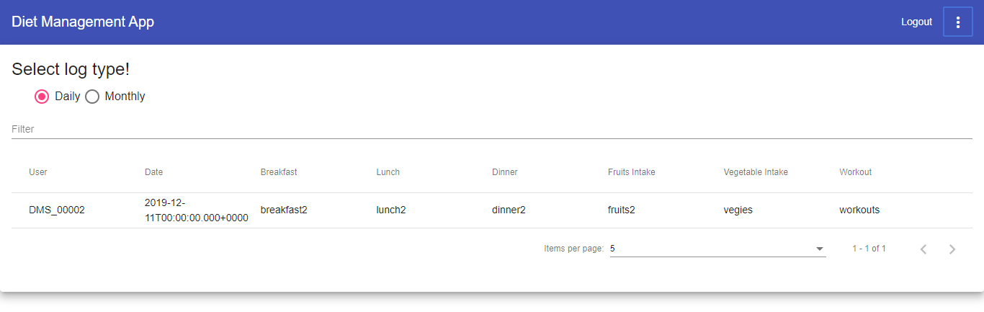

6. **Admin – View monthly user measurement logs**:  
  
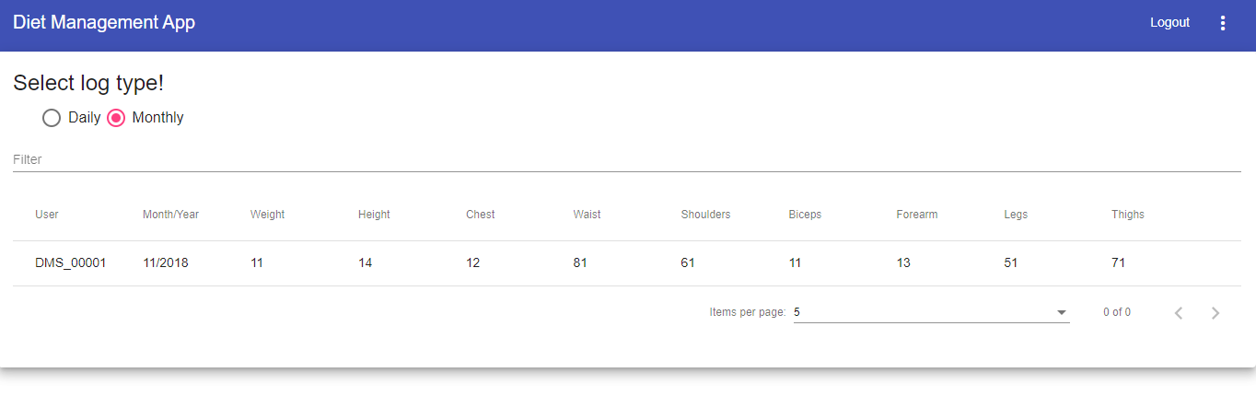

7. Admin – Add User:

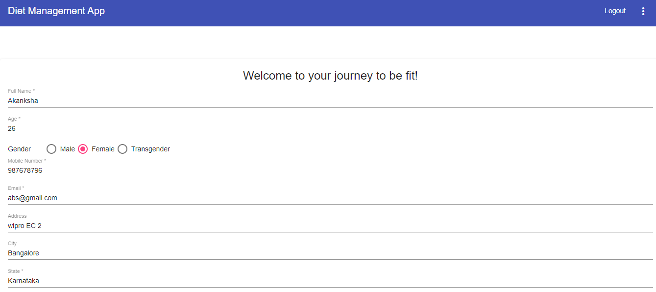

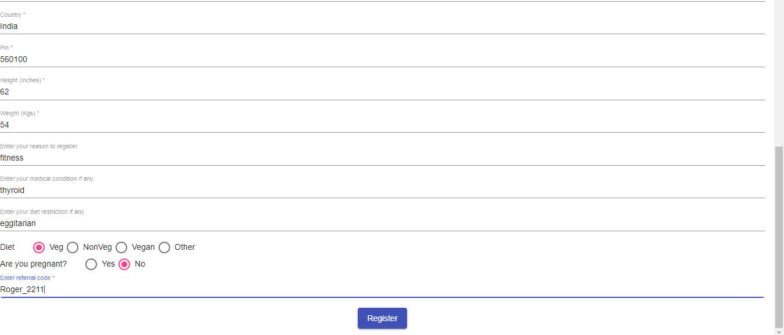

8. **Mail Sending Feature** :   
  
 Based on Approval/Rejection of admin, appropriate mails will be sent to concerned User Mail ID.

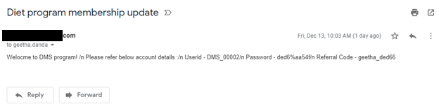

7. **Chat feature** :   
  
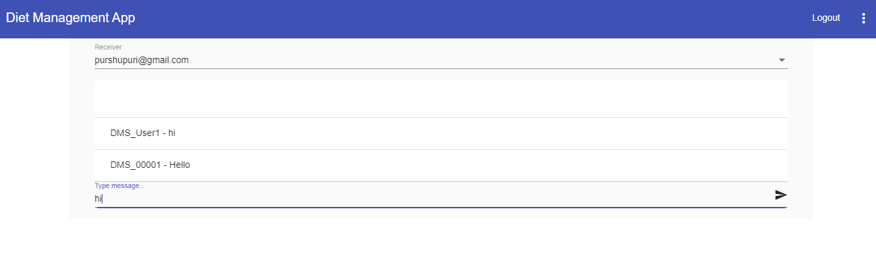

8. **Moderator - Menu** :   
  
 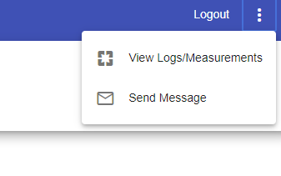

**9. User Menu :**  
  
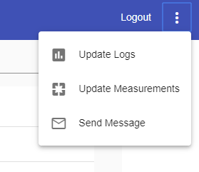

10. **User – Add Daily activity log** :

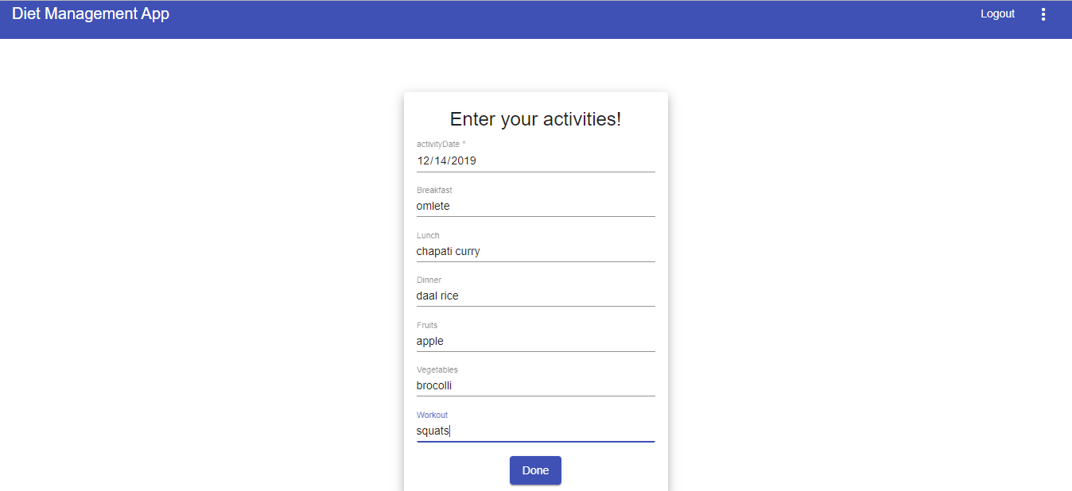

11. **User – Add Monthly measurements** :

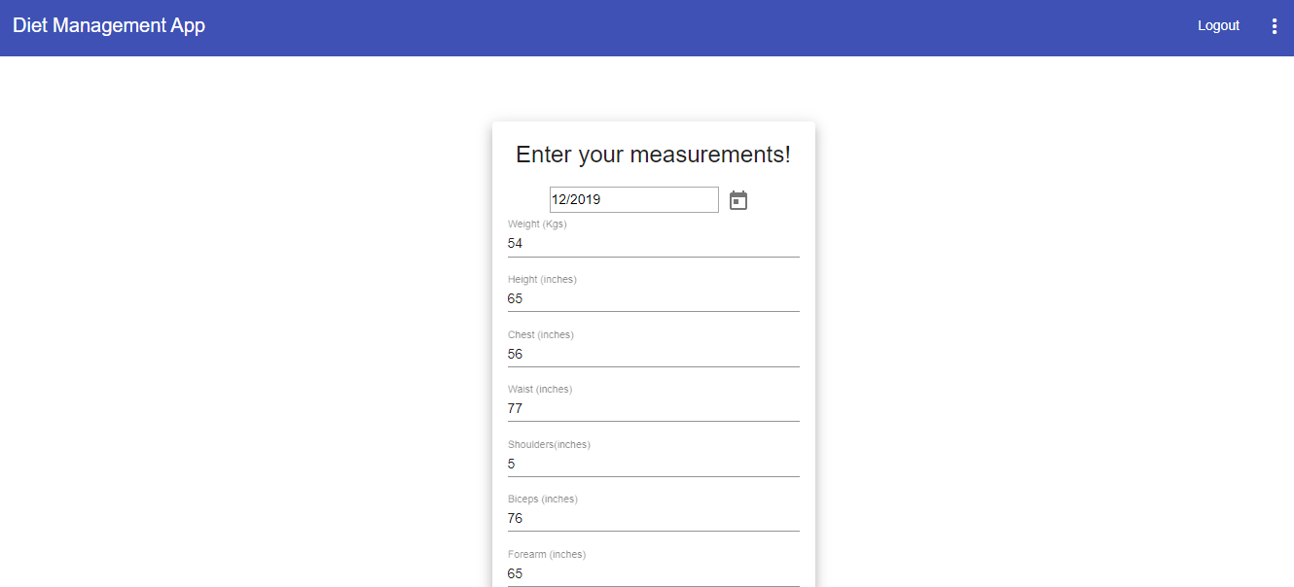



**Future Enhancements :**

* Group chat.
* Diet plan upload.
* Session management.